Computer Graphics Class Assignment 1

2015004493

김형순

1. How to run program

You can run program by just run classAssignment1.py code. When you run program, you can see the dog is walking! (It is dog not cow.) If you want to change speed of the dog, you can press keyboard button ‘1’ and ‘3’. You can speed up by pressing ‘1’, and you can speed down by pressing ‘3’. If you press ‘3’ many times, the dog even walk backward.

2. Implemented requirements

1-1) Orbit:

You can rotate camera around target point by click mouse left button and drag. It is similar with MMB in blender. You can find this part in function button_callback and cursor_callback.

1-2) Panning

You can move both target point and camera with left, right, up, down direction of camera by click mouse right button and drag. It is similar with Shift – MMB in Blender. You can find this part in function button_callback and cursor_callback2.

1-3) Zooming

You can move forward and backward camera by rotating mouse wheel. It is similar with Ctrl – MMB in Blender. You can find this part in function scroll_callback.

1-4) XY plane

I drew xy palne with 20 * 20 rectangular grid. I also added coordinate axis for reference. You can find this part in function drawFrame.

2-1) Hierarchy model

I made the dog with hierarchy system. The dog is consisted with 5-level hierarchy model. Hierarchy structure is presented in end of report.

2-2) Animating the model

I animated the dog by waking around xy plane. The dog rotate around (0, 0) point. I rotated dog’s body. Dog’s each leg moves and each pipe(관절) rotates. I tried to make the dog’s movement looks like real – life dog by making mathematical function for each pipe. The function is presented in end of report.

3. Some developing notes

1) First I tried to rotate and move camera by getting angle and position with geometric calculation and use gluLookAt. But it was so hard to implement because rotation, panning and zooming should work in local coordinates. So, I introduced accumulating notion to valid movement in local coordinates. You can see accumulator and elav_accimulator matrix in code.

2) To associate click and drag of mouse, I decided to change cursor callback function when mouse button is clicked. You can check in button_callback function.

4. Hierarchy structure of the dog 5. Function for dog’s leg

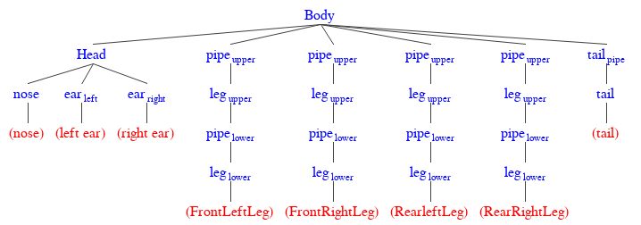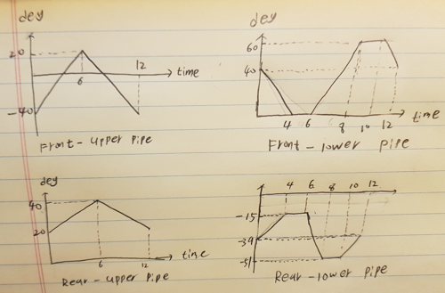

6. Some screenshots

